Hello!
My name is Abril Prats Masegosa and I’m 16 years old. I live in Alqueria d’Asnar with my family. It takes me 8 minutes to go to school in Muro, because Alqueria is near Muro and I go to school by bus.
In my family we are four people, my mum Manuela, my dad Juan and my sister Telma.
I'm generous and pleasant. I am very sporty and quite sociable.
I'm afraid of spiders. I'm good at clarinet and guitar. I'm so bad at drawing.
Right now I’m studying first bachillerato at IES Serra Mariola, in Muro. The subjects I like the most is Maths, Biology, and Physics; so I will choose the science line.
I play the clarinet in Muro’s band, and the guitar too, in a ska/rock group of music, we play my friends and I, I love music. Now I’m learning piano, but I’m only starting.
In my spare time I play the clarinet and the guitar but I hang out with my friends too.
I also like to spend time with my family, I usually ride a bike with my father, I usually go running with my mother, and I often help my sister because she is starting to learn how to play the flute.
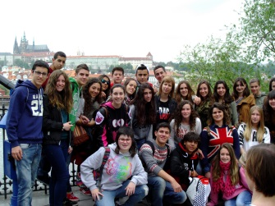 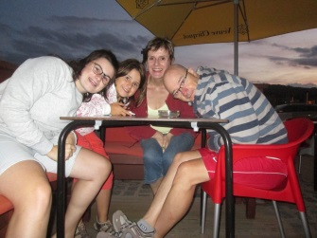 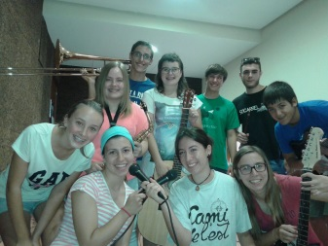
MY FRIENDS MY FAMILY TARANNÀ (MY GROUP)
BUMM

