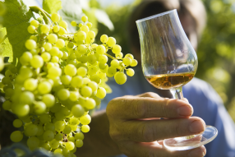
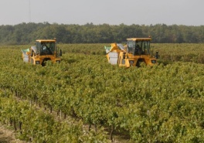
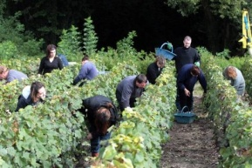
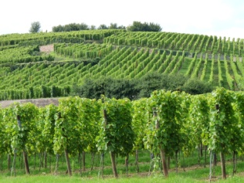
The grape harvest in the Cognac country are always in October because for us this is where the wine is the best. Grapes either by hand or with machines are harvested. And maybe later you would taste one of our specialties.
Maybe your parents or teachers have already tasted one of our local "drinks" ?

